**Hazard Analysis**

**Arizona State University Team**

Shannon Ault, Calvin Birr, Sara Fletcher, Brandon Larson

**Risk Assessment Matrix**

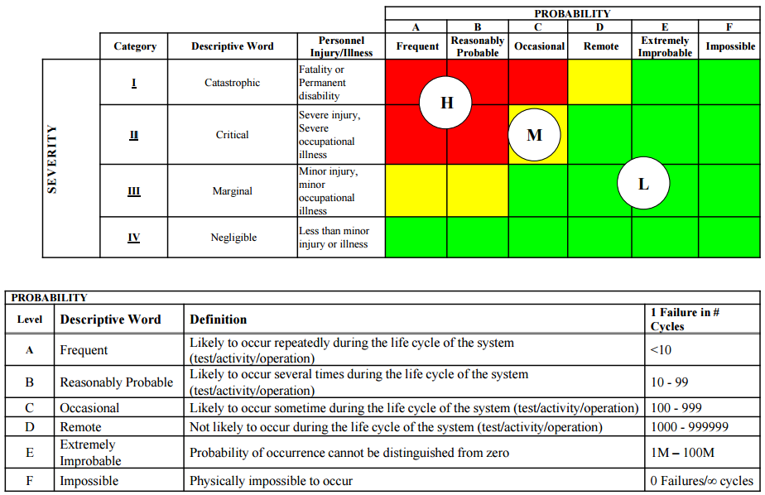

|  |  |  |  |  |  |
| --- | --- | --- | --- | --- | --- |
| **Hazard** | **Cause** | **Effect** | **RPC** | **Countermeasures** | **New RPC** |
| Collision with personnel on ground | Loss of control of mule or someone in its path. | Crush injuries: broken bones, bruising, and/or internal bleeding. | **H** | Reflectors and light installed on mule to be more easily seen, emergency brakes, and a kill switch. | **M** |
|
|
|
| Lifting injury | Loading and unloading mule from transport. | Back injuries or injuries from mule being dropped. | **H** | A winch can be used to lower and raise mule in to transport. | **L** |
| Electrical Fire | Overheating or too much amperage sent through system | Up to third degree burns covering under 5% of body. | **M** | Electrical circuit contained within steel box. | **L** |
|
| Collision with object while carrying personnel | Human error, electrical or mechanical malfunction. | Minor injuries sustained, worst case scenario a broken arm or concussion. | **M** | Speed cannot surpass 15 mph, straps installed for holding stretchers in place. | **L** |
|
| Lead acid exposure | Lead acid leaking from batteries. | Minor acid burns. | **L** | Batteries are contained in steel box. | **L** |
|
|
|